**“Experiment 2.2”**

Student Name: **SUMIT KUMAR** UID: **20BCS8226**

Branch: **CSE** Section/Group: **808-A**

Semester: **5** Date of Submission: **28-10-22**

Subject Name: **PBLJ Lab** Subject Code: **20CSP-321**

**Aim:**

**Write a Program to collect and groups the card.**

**Minimum Hardware Requirements:**

* 2 GHz CPU or 1 virtual CPU in virtualized environments.
* 1 GB of RAM.
* 4 GB of storage.

**Minimum Software Requirements:**

|  |  |
| --- | --- |
| **Software** | **Version** |
| * OS | * Mac OS 10.15, HP-UX 11i V3, AIX 7.2, Windows Server 2019, Windows 10, Solaris 11.3, Red Hat Enterprise Linux 8.1, Ubuntu Server 20.04 |
| * JDK | * JDK 1.8.0, JDK 11, Ellipse IDE, Net, NetBeans 8.2 |

**Source Code:**

**// Save:** **GroupCards.java**

// SUMIT KUMAR

// 20BCS8226

**package** practice2;

**import** java.util.ArrayList;

**import** java.util.Iterator;

**import** java.util.Map;

**import** java.util.Map.Entry;

**import** java.util.Scanner;

**import** java.util.Set;

**import** java.util.TreeMap;

**public** **class** GroupCards {

**public** **static** **void** main(String[] args) {

Scanner sc = **new** Scanner(System.***in***);

Map<Character, ArrayList<Card>> map = **new** TreeMap<>();

System.***out***.println("Enter Number of Cards :");

**int** n = sc.nextInt();

sc.nextLine();

**for** (**int** i = 1; i <= n; i++) {

System.***out***.println("Enter card " + n);

**char** symbol = sc.nextLine().charAt(0);

**int** number = sc.nextInt();

Card card = **new** Card();

card.setSymbol(symbol);

card.setNumber(number);

sc.nextLine();

**if** (!map.containsKey(symbol)) {

ArrayList<Card> list = **new** ArrayList<>();

list.add(card);

map.put(symbol, list);

} **else** {

ArrayList<Card> list = map.get(symbol);

list.add(card);

}

}

System.***out***.println("Distinct Symbols are :");

Set<Entry<Character, ArrayList<Card>>> set = map.entrySet();

Iterator<Entry<Character, ArrayList<Card>>> it = set.iterator();

**while** (it.hasNext()) {

System.***out***.print(it.next().getKey() + " ");

}

System.***out***.println();

set = map.entrySet();

it = set.iterator();

**while** (it.hasNext()) {

**int** sum = 0;

Map.Entry<Character, ArrayList<Card>> me = it.next();

ArrayList<Card> list = me.getValue();

System.***out***.println("Cards in " + me.getKey() + " Symbol");

**for** (Card card : list) {

System.***out***.println(card.getSymbol() + " " + card.getNumber());

sum += card.getNumber();

}

System.***out***.println("Number of cards : " + list.size());

System.***out***.println("Sum of Numbers : " + sum);

}

sc.close();

}

}

**// Save: Card.java**

**package** practice2;

**public** **class** Card **implements** Comparable<Card>

{

**private** **char** symbol;

**private** **int** number;

**public** Card() {}

**public** Card(**char** symbol, **int** number) {

**super**();

**this**.symbol = symbol;

**this**.number = number;

}

**public** **char** getSymbol() {

**return** symbol;

}

**public** **void** setSymbol(**char** symbol) {

**this**.symbol = symbol;

}

**public** **int** getNumber() {

**return** number;

}

**public** **void** setNumber(**int** number) {

**this**.number = number;

}

@Override

**public** String toString() {

**return** "Card [symbol=" + symbol + ", number=" + number + "]";

}

@Override

**public** **int** compareTo(Card o) {

**if** (**this**.symbol < o.symbol) **return** -1;

**else** **if** (**this**.symbol > o.symbol) **return** 1;

**else** **return** 1;

}

// @Override

// public int hashCode() {

// return String.valueOf(symbol).hashCode();

// }

// @Override

// public boolean equals(Object obj){

// if (obj instanceof Card) {

// Card card = (Card) obj;

// return (card.symbol == this.symbol);

// } else {

// return false;

// }

// }

}

**Output:**

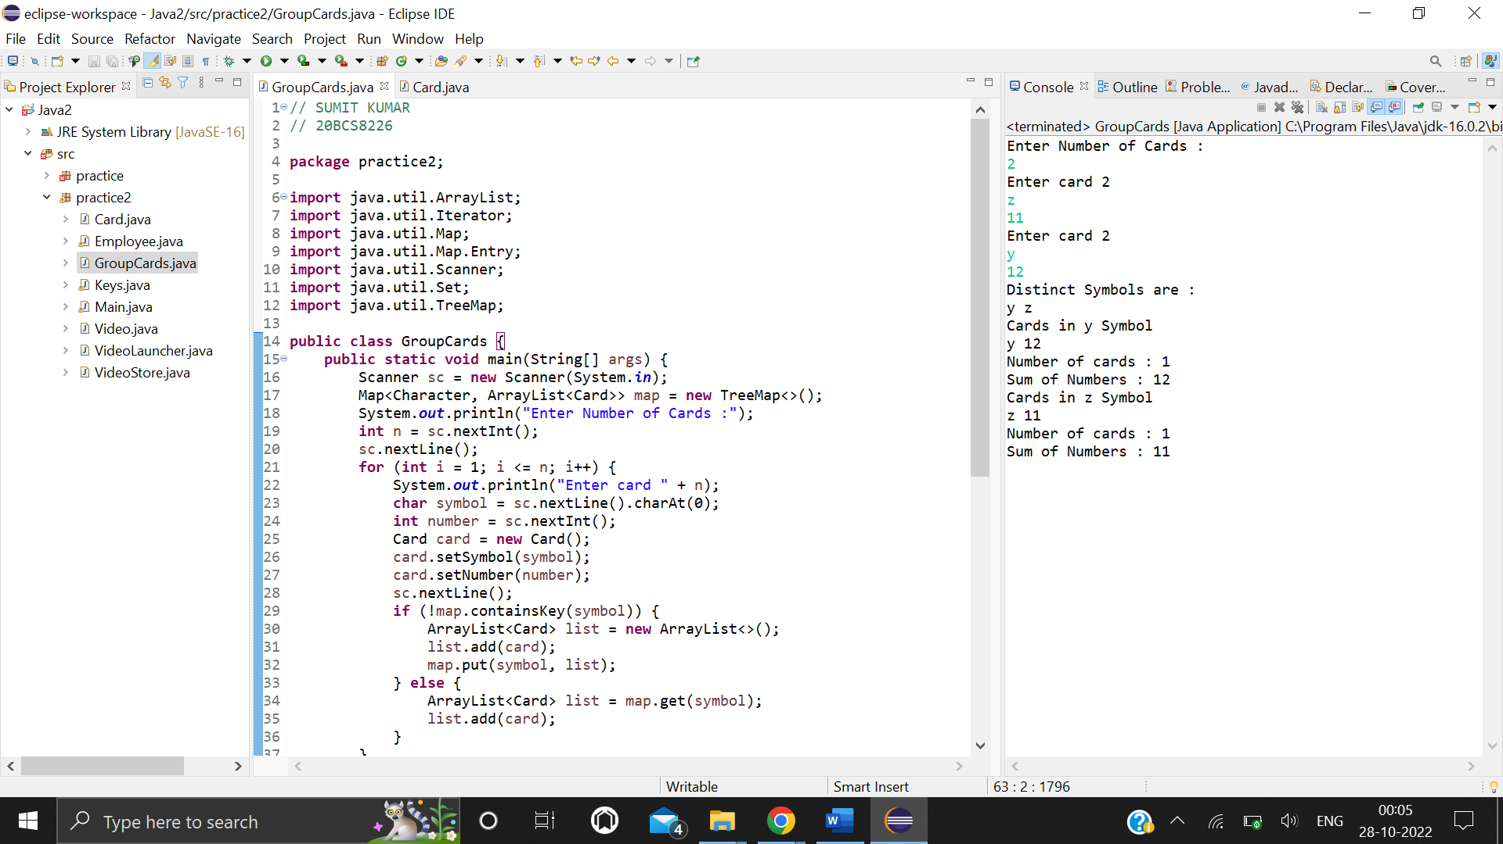

**Learning outcomes:**

**1.** We have implemented the hash map using the java collection framework.

**2.** I’ve performed the insertion of data into hashmap using the scanner class of java.

**3.** I have gone through the uses of for loop for taking the input from user in iterative way.

**4.** Used two data types which String as key and Integer as value pair. Hashmap data structure is mainly used for insert the value in the key and value pair.